To: Toronto Board of Health
Re: 2018.HL26.1, Re-affirming the City of Toronto as a Nuclear Weapons-Free Zone.

April 16, 2018

I am speaking here today on behalf of Canadian Voice of Women for Peace. Our organization was formed in 1960 in response to public concern over the accelerating nuclear arms race. In particular VOW expressed the concern of mothers for the safety of their children, and for their future well-being.

VOW participated actively in campaigns to educate the public about the dangers posed by nuclear weapons. VOW members gathered baby teeth to be sent for measurement for strontium 90, one of the radioactive components released by atmospheric tests. In the decades since winning a partial test ban treaty in 1963 VOW has continued our opposition to nuclear war and our commitment to building a culture of peace.

In 1982 I participated in a march of nearly one million people in New York City calling for the abolition of nuclear weapons and the funding of human and environmental needs.

Most recently VOW’s work has been as a member of the International Campaign for the Abolition of Nuclear Weapons, ICAN, which in December of 2017 was awarded the Nobel Peace Prize.

Cities are ground zero for attack if and when there should ever by a nuclear ‘exchange’ as people like to politely call it. Instead we call it annihilation.

Here is a photo from Hiroshima after the atomic bombing. You can see the physical destruction of infrastructure. What you can’t see is the impact of radiation which went on to kill many tens of thousands more in addition to the 80,000 immediately killed.

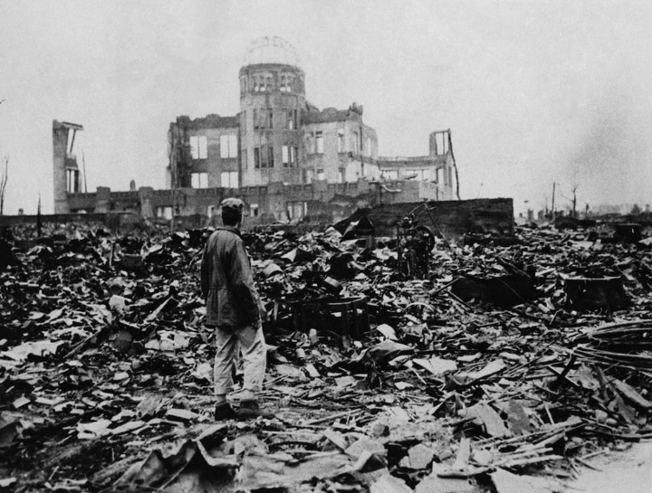

Now nuclear weapons are routinely deployed around the world on a ready to launch basis and some of these weapons have 1000 times greater destructive power than the bomb that was dropped on Hiroshima.

I am relieved to live in a city that has declared itself a nuclear-weapons free zone. By renewing our commitment we are publicly acknowledging the dangers that nuclear weapons pose to our city. We are not hiding our heads in the sand and pretending it will go away.

Now I hope that we will go one step further and advocate to our federal government that Canada sign the nuclear weapons ban treaty. This is an historic opportunity for Canada to play an extremely useful role in the world in a turning point that must come. This turning point, the commitment to the abolition of these weapons of mass destruction, must come in the very near future if we are to prevent a catastrophe of immense magnitude.

Canada has not signed on despite the fact that the vast majority of Torontonians support nuclear disarmament.* Canada is under pressure from NATO and the USA not to sign the ban treaty. However Canada has publicly declared that we have an independent foreign policy. On the issue of land mines Canada played a vital leadership role in achieving a land mines ban treaty.

If we are to see Canada sign the Treaty on the Prohibition of Nuclear Weapons we must see sufficient pressure brought to bear on the government to act in this moment of opportunity. We must show that Canadians care.

The world has changed since 1945. We have built the infrastructure of the UN and other world bodies in order to discuss and resolve global conflicts. The field of mediation and conflict resolution has been developed and expanded around the world. We know how to develop win-win resolutions. It is time to use these skills and these international bodies to resolve existing conflicts and prevent future wars – not to rely on the threat of the use of weapons of mass destruction to maintain ‘peace’.

Ursula Franklin, one of VOW’s more prominent members, said ‘peace is not the absence of war, peace is the presence of justice and the absence of fear’.

It is an extremely important time to bring the commitment of the City to bear on this grave concern, to speak up for the health and future wellbeing of our city and our citizens.

We are proud that Setsuko Thurlow, one of VOW’s members, played an instrumental role in the adoption of a nuclear test ban treaty at the UN in June of last year. We rejoiced with her in the acceptance of the Nobel Peace Prize. Now let us stand with her to make sure that the Treaty on the Prohibition of Nuclear Weapons is publicly supported by this Council.

I thank you for the opportunity to speak.

Lyn Adamson, Co-Chair
Canadian Voice of Women for Peace
579 Kingston Road, Suite 125, Toronto, ON, M4E 1R3
www.vowpeace.org; info@vowpeace.org,

*In November 1982 78% of Torontonians voted in support of the following resolution “Do you support nuclear disarmament by all nations on a gradual basis to the ultimate goal of a world free of nuclear weapons, and mandate your federal government to negotiate and implement, with other governments steps which would lead to the earliest possible achievement of this goal?”

